**EX:No.4 STATIONARITY CHECK 221501016 04/03/25**

**AIM :** To implement stationarity check using Augmented Dickey Fuller test and Visualise it.

**PROCEDURE:**

1. Read the time-series data from the CSV file.

2. Convert the date column to datetime format and set it as the index.

3. Visualize the data using a line graph.

4. Apply the Augmented Dickey-Fuller (ADF) test to check stationarity.

5. Print the ADF statistic, p-value, and critical values.

6. Determine if the series is stationary based on the p-value.

**IMPLEMENTATION :**

import pandas as pd

import matplotlib.pyplot as plt

from statsmodels.tsa.stattools import adfuller

**Load the dataset**

file_path = "/mnt/data/Electric_Production.csv"

df = pd.read_csv(file_path)

**Convert DATE column to datetime format**

df["DATE"] = pd.to_datetime(df["DATE"])

df.set_index("DATE", inplace=True)

**Perform Augmented Dickey-Fuller test**

def adf_test(series):

result = adfuller(series)

print("ADF Statistic:", result[0])

print("p-value:", result[1])

print("Critical Values:")

for key, value in result[4].items():

print(f" {key}: {value}")

if result[1] <= 0.05:

print("Conclusion: The series is stationary.")

else:

print("Conclusion: The series is non-stationary.")

return result

**Plot the original time series**

plt.figure(figsize=(10, 5))

plt.plot(df["IPG2211A2N"], label="Electric Production", color="blue")

plt.title("Electric Production Over Time")

plt.xlabel("Year")

plt.ylabel("Production Value")

plt.legend()

plt.show()

**ADF Test on original data**

print("ADF Test on Original Data:")

adf_test(df["IPG2211A2N"])

**OUTPUT:**

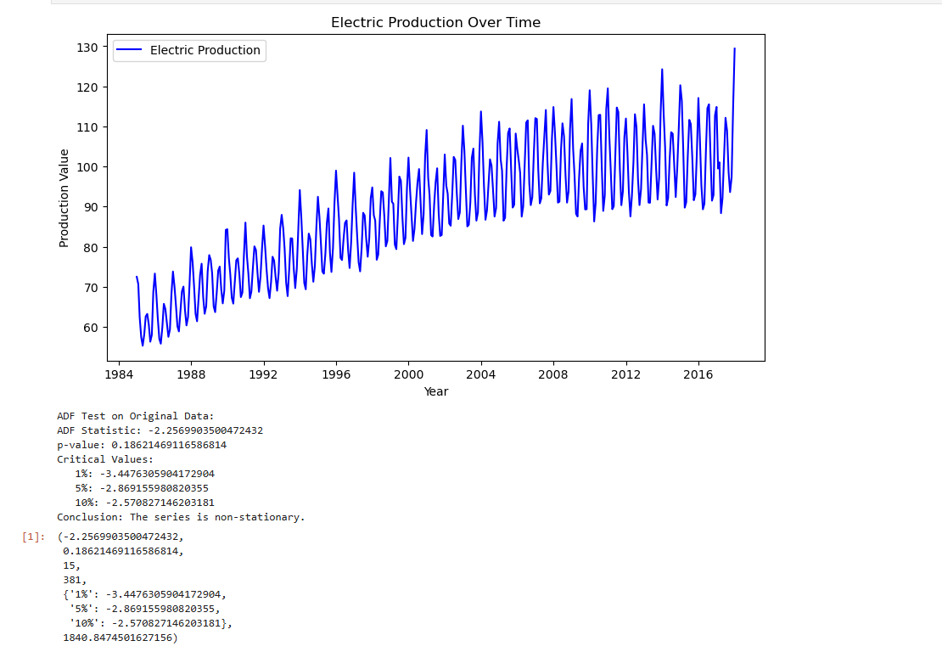

**RESULT :** Thus stationarity check has been implemented successfully using Augmented Dickey Fuller Test.